**WEB PROGRAMMING PT.2 REPORT**

MEMBERS:

1. Farrelio Gustiana Dzaki (Leader)
2. Muhammad Aldi Apriansyah
3. Muhammad Praditya Abyan
4. Revokatus Ivo Ardi Pradipa

We make a simple online shop platform like Amazon, Tokopedia, Shopee, etc. So, our website begins from the landing page.

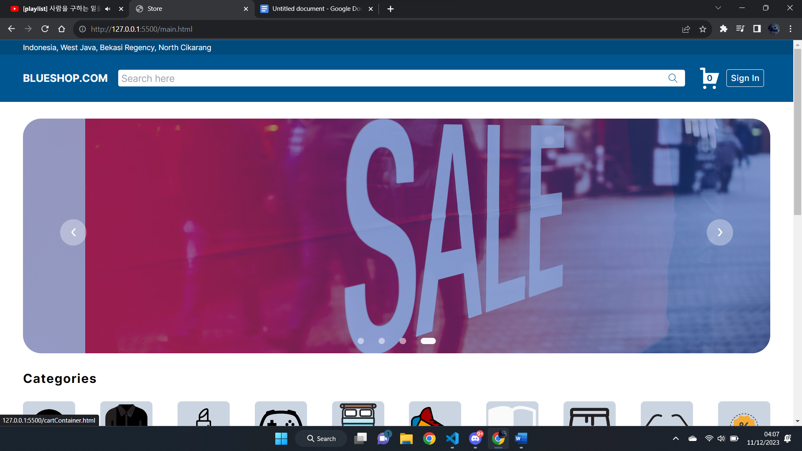

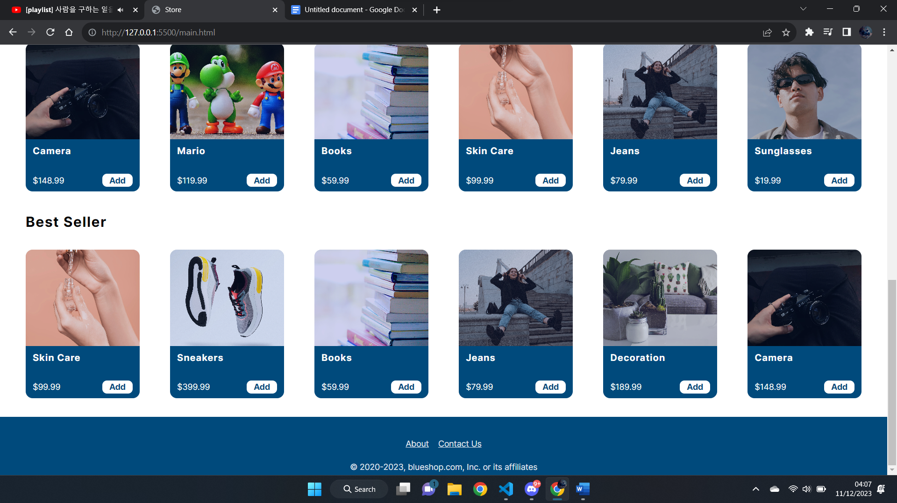

And this Is our landing page. From the header we have the location of the user, our platform name sign in button to go to the sign in page and cart to go to the shopping list page.

Then below the header we have a slider of some images that shows that we have many promos. The slider we automatically swipe every 2 seconds. We use **setInterval()** to make the slide automatically slide for every 2000 milliseconds. Then there is a left and right button. When the user clicks the left button the slide will swipe the image to the left and when the user clicks the right button the slide will swipe the image to the right. For the left and right buttons, we use jQuery **click()**. So basically, the images of the slider have their own divs for their container and we name all the divs with the same class, so when we call it with jQuery we will get an array. Then we make another variable using **let** for the index. So, when the user clicks the right button, the index will be plus by one and when the user clicks the left button it will be subtract by one. But to prevent the index from getting numbers that below 0 and above the last index we use If else to prevent that.

Below the slider we have categories then we don’t put any JavaScript in the categories section. Then below the categories section we have some goods that sell on our platform. And we put an add button in the card of the products. So, when the user clicks the add button the number in the cart will be plus by one. We use click() in the add button where in the function the image, price and the name of the products data will be put in the array which contains some objects. And to make it not reset to 0 when the web gets refreshed we use localStorage.setItem() in the add function and to get the data we use localStorage.getItem(). We set the data change to be a string using JSON.stringify and we get the object using JSON.parse to get the data in an array.

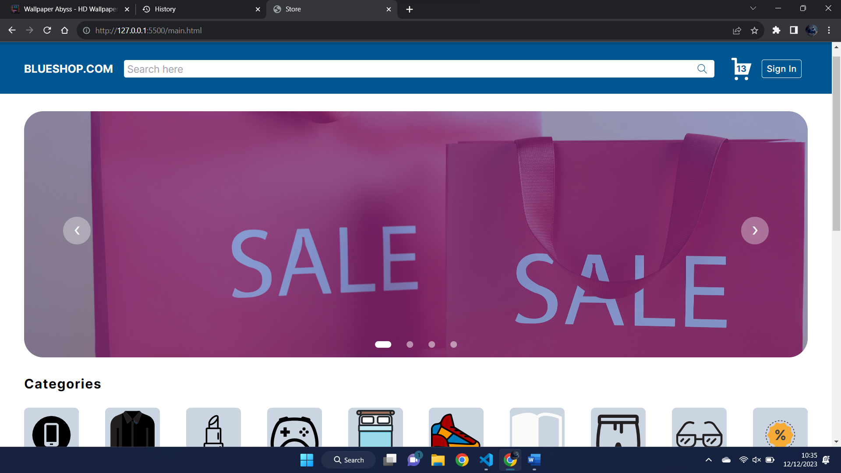

That’s the result if the user clicks the add button.

Before going to the very bottom of the landing page, in the header there’s a cart. When the user clicks the add button the number in the cart will be plus by one. When the user clicks the cart. It will move to the shop list page.

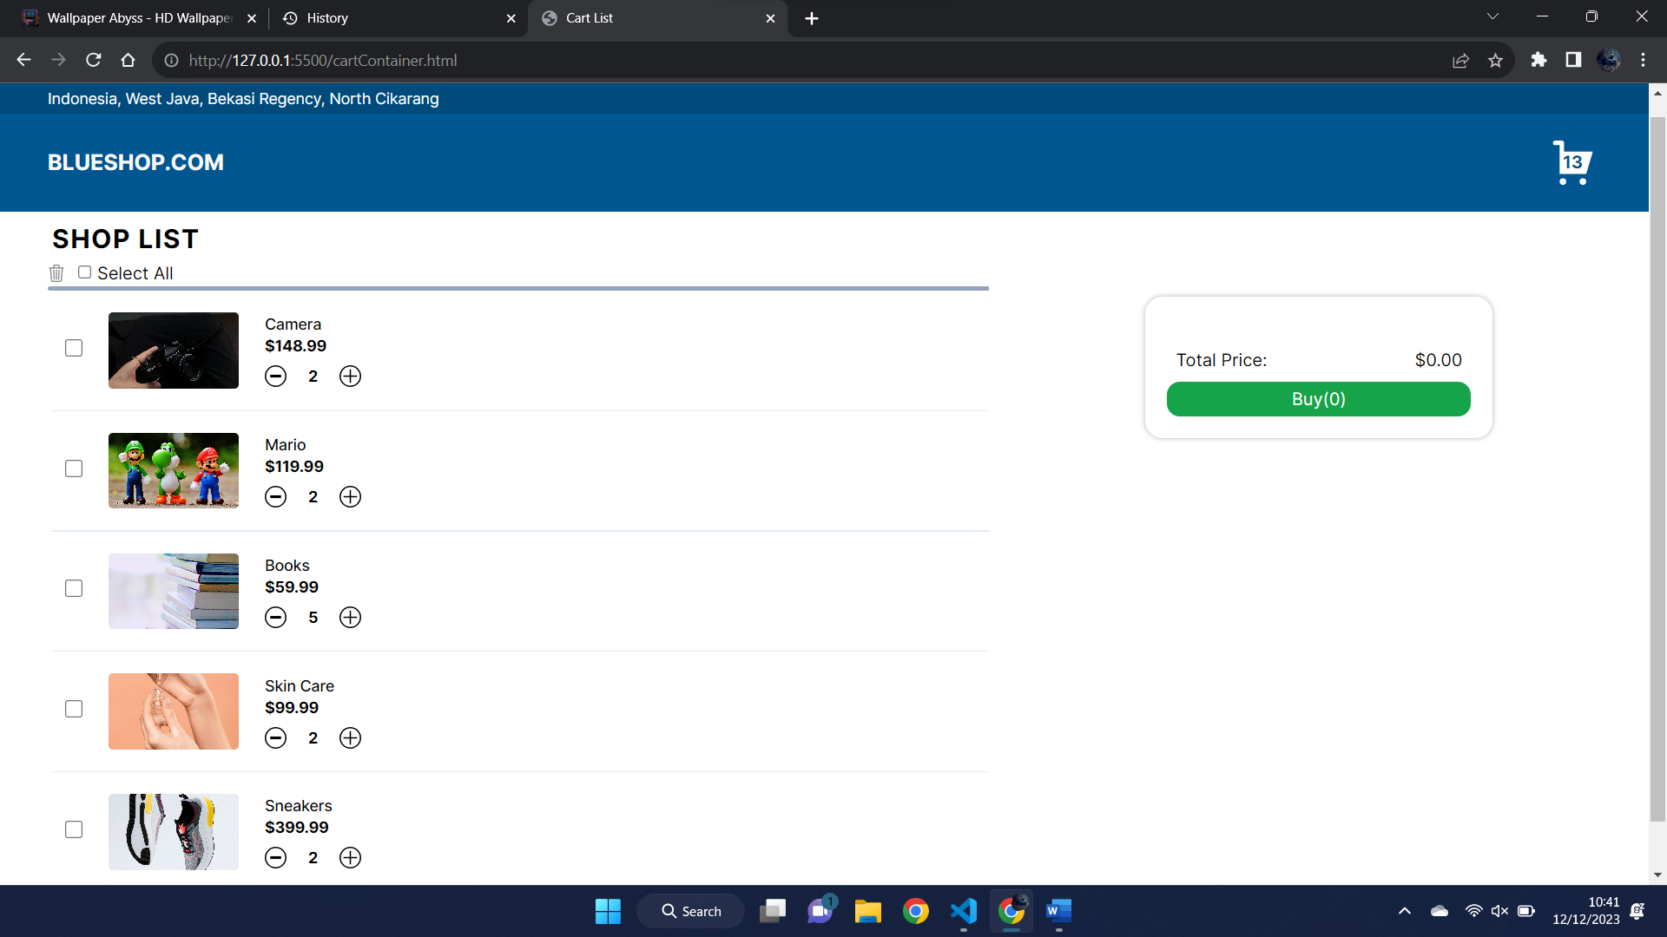

As we can see the cart numbers didn’t reset to 0 again and the data is displayed in the page. So the keys in each object are name, price, image, and the count. So if the user clicks the add button in the same product the count will be increased by one. So we add increments in the add button function.

So, in this shop list page the item that contains in the data will display like the picture above with an additional feature minus and plus buttons. And the number between those buttons is the count, or the amount of the products that the user wants to purchase. Everytime the user clicks the minus button the count will be minus by one, and if the user clicks the plus button the count will be plus by one. We put increment in the function of the plus button and decrement in the function of the minus button. And we use jQuery **click()** to those two buttons. But in the minus button if the count reaches number 0 the content will be removed. To do that we use **splice()** for the shop list data and for the DOM we use **remove()** and we use a loop to identify the index of the goods.

If the user clicks some of the checkbox input then the price and the amount of the goods will be displayed on the right side. To do that we use **change()**, inside the change we put a loop and check if the input is checked or not, if the input is checked then we take the index to know where the data is. If the first goods is checked then we get the index 0. After we get the index we find the price and the amount of the goods from the index that we get, after that we display it.

Then below the shop list title we have, select all checkbox. When the user clicks the checkbox then all the checkboxes in the display will be checked. To do that we use **click()** on the input of select all and we put a loop in there so all the input will be checked too. And we add a feature when all the inputs are checked then the select all input will be auto checked. To do that we put a function that has a boolean true, then if one of the inputs is not checked it turns to false. When the boolean is true that means all the inputs are checked then the select all button will be checked. But if the boolean is false that means, one of the inputs are not checked then the select all button will be automatically not checked.

Then beside the select all input there is a trash can icon which if you hover it, it will show text “click here or press e in your keyboard to clear your shop list”. To show the text we use **mousemove()** and use **css()**. Then we make the users able to clear shop lists or to delete all the by pressing the e button by using **keypress()** and to clear it by clicking the trash can icon by using **click()**. In the function inside we use localStorage.clear() to clear the local storage and we make the length equals to 0. Then we use if else if the data length 0 it will show not found text like this.

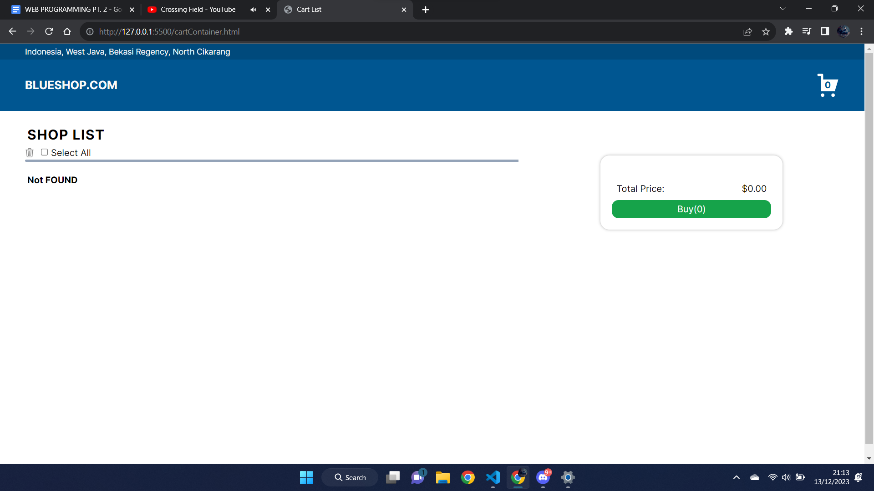

The output will look like that if there are no items added in the shop cart.

Then back to the purchase feature. If the user doesn’t choose to check any input it will pop up alert like this.

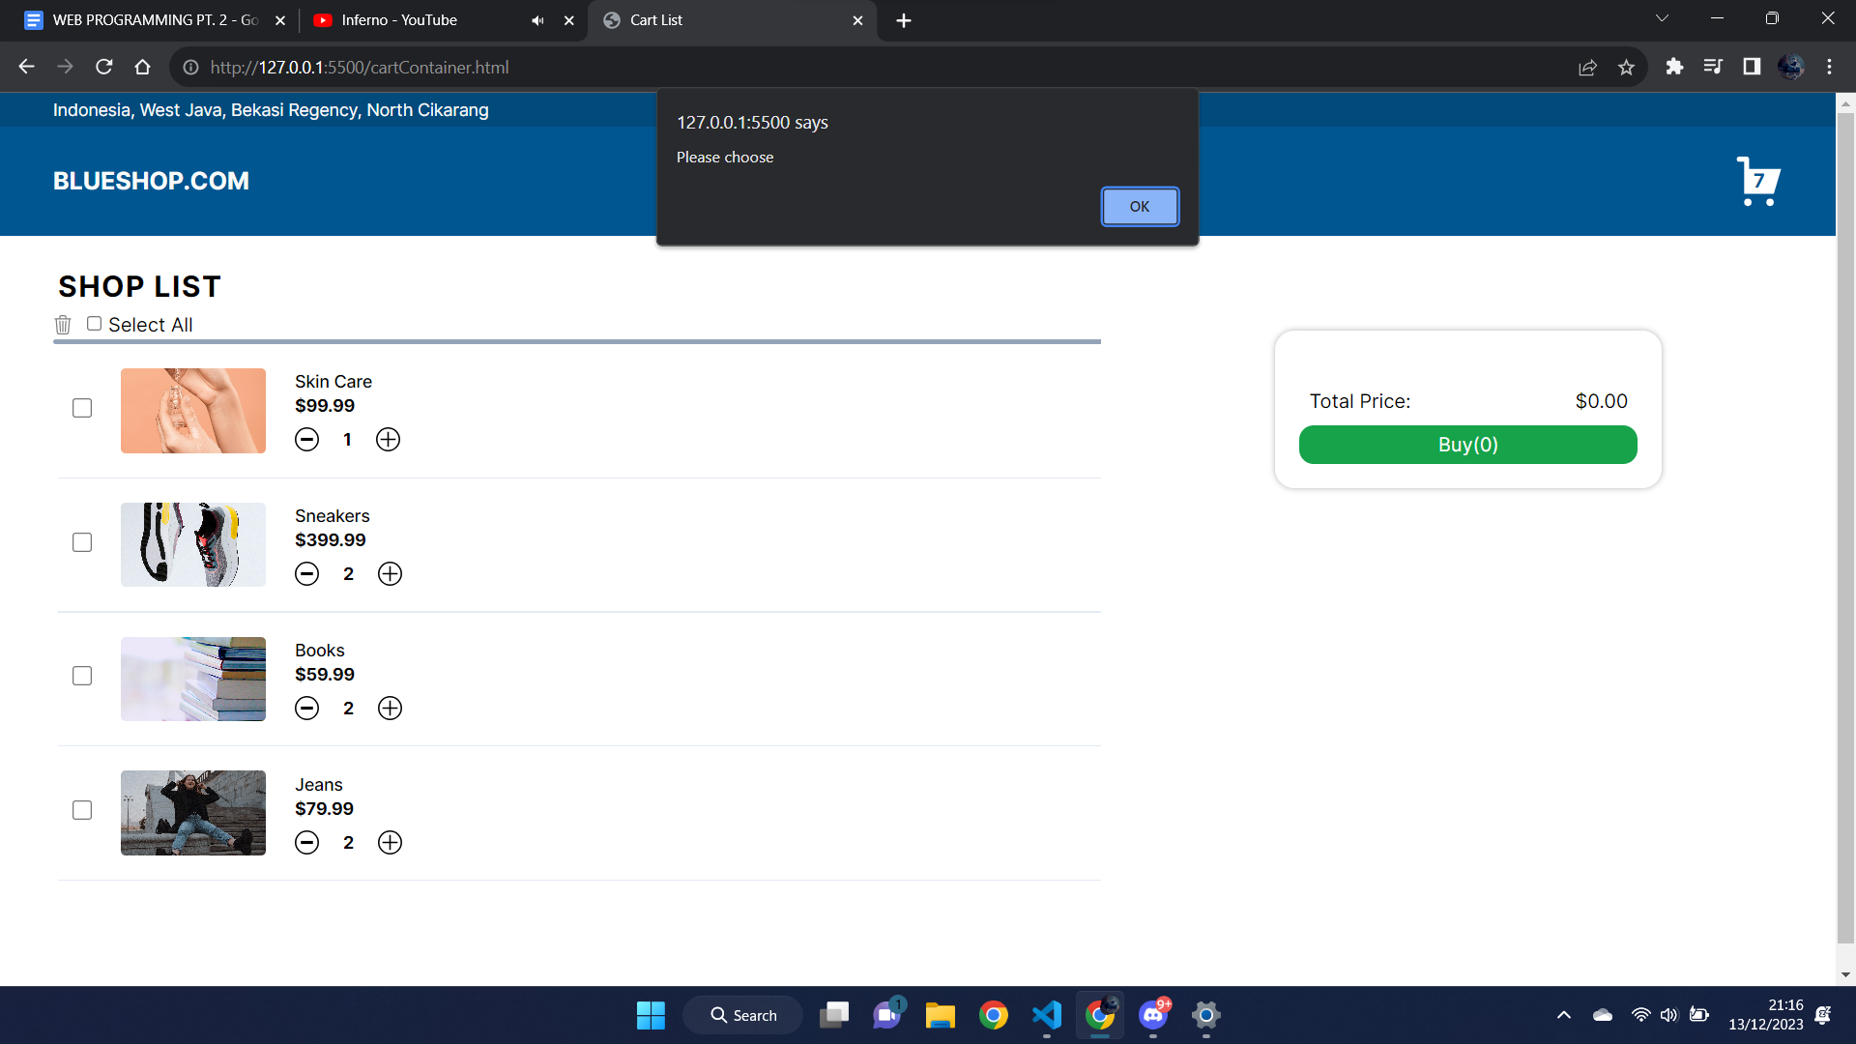

So this makes the user need to check one of the checkboxes. To do that we use a loop at the checkboxes input and if else, it is checking. If there is none of the checkboxes checked then it will trigger the alert and the preventDefault().

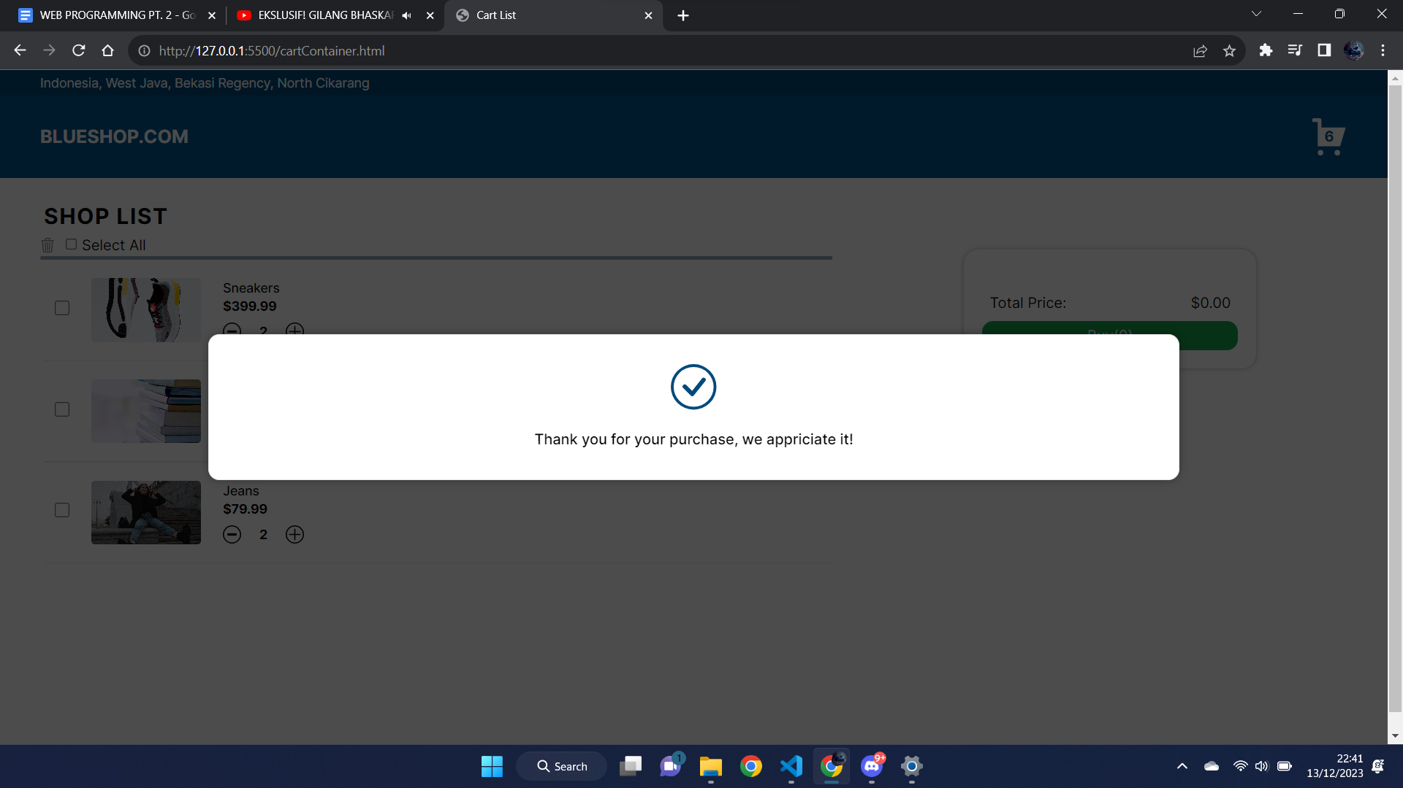

Then if the user clicks some of the items then the clicks buy button or enter it will pop up a message like this. Then after it pops a message like this it will auto refresh in 1s or 1000ms. To do that we use **removeClass()** in the **submit()** to remove the class that contains display none, because we use tailwind css. Then we use setTimeout to make it refresh after 1s.

After that the item that the user picks to buy the display will be removed and the data if the item will be removed. To do that we use loop and if else. We loop the input checkboxes then the program will check which index that the input is checked, then after we get the index the data of the index will be **splice()** and the DOM will be removed using **remove()**. Then the cart number will be minus by the amount of the item of the index that we get.

Then we move again to the main page. If you page the logo it will go to the main page.

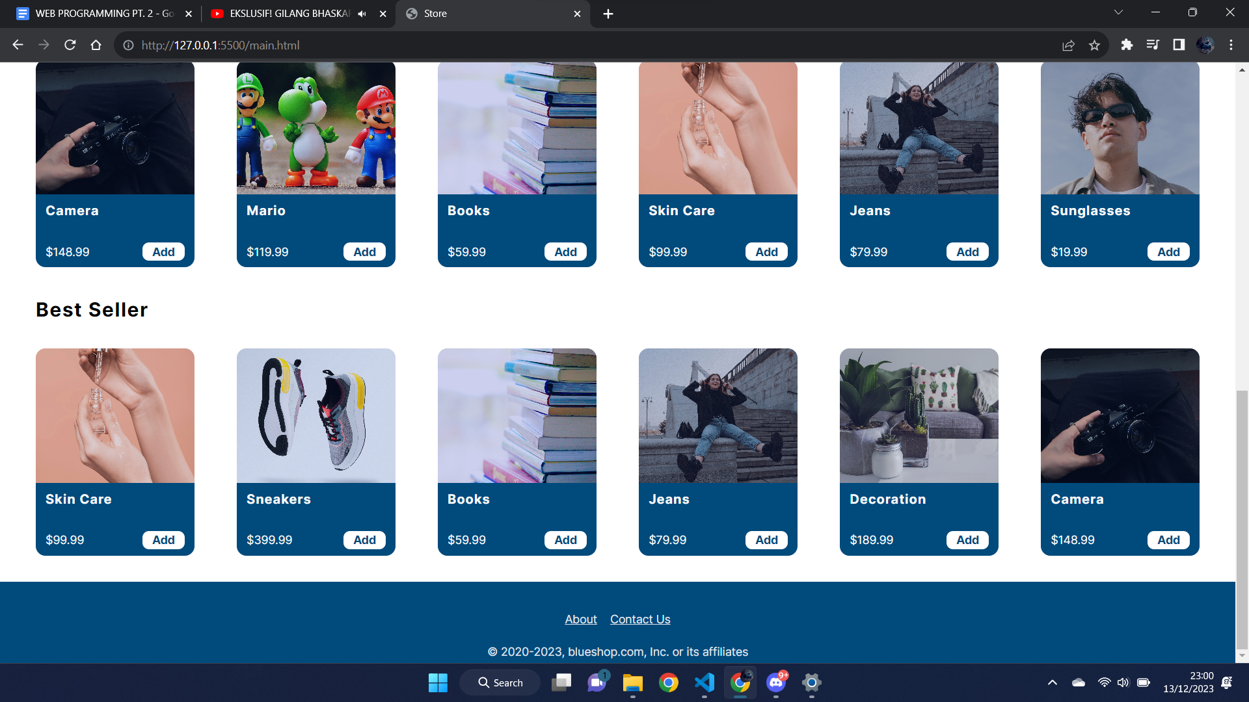

And this is the footer of our main page. In the footer there is a link to click to move to the contact us page and about page.

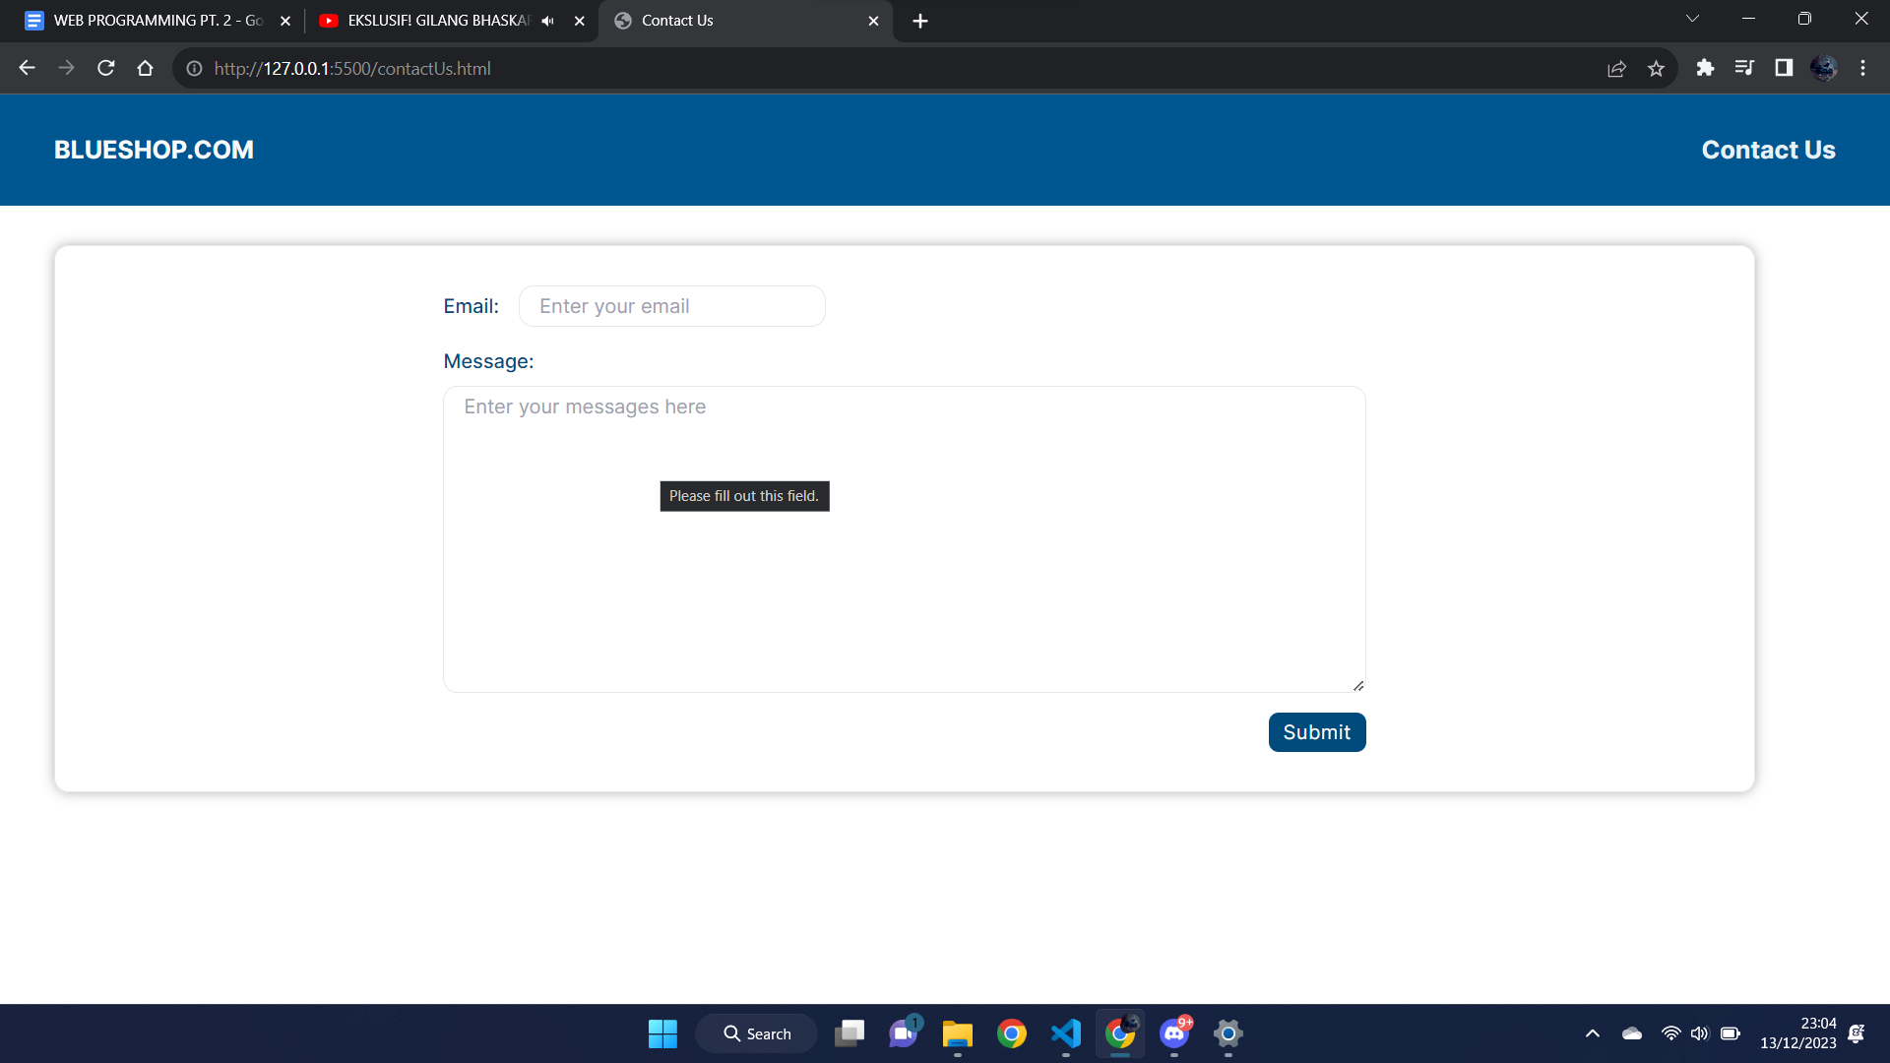

And this is our contact us page, in our contact page we put required attributes in the input and the textarea to make sure that the users can’t submit before they fill the input.

In the textarea if the user wants to fill the textarea then the border color of the textarea will be changed. To do that we use **focus()** into the textarea, then the function inside we put **addClass()** that contains the color of the border that we want.

Then if the user submits it will pop up a message like this.

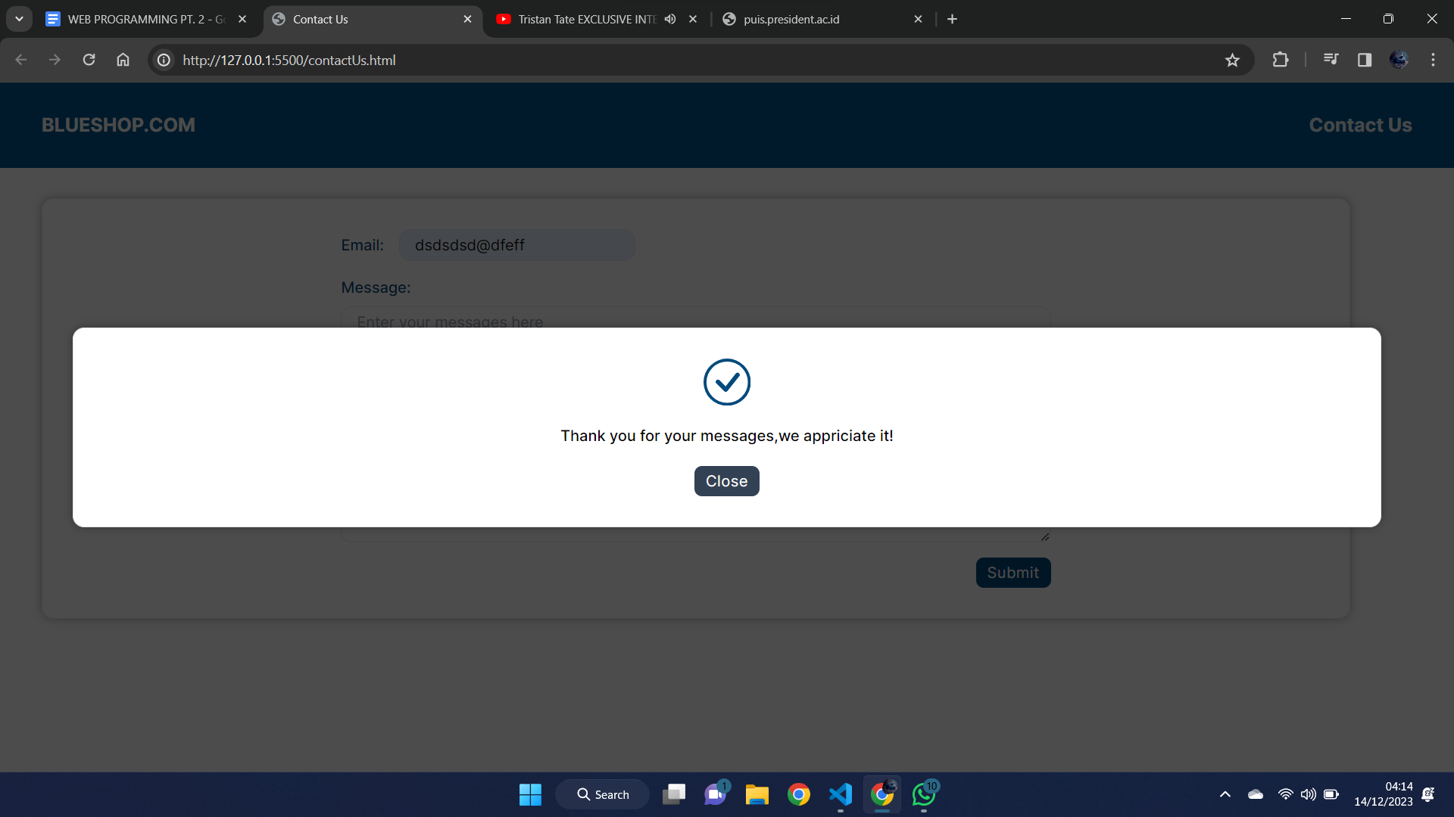

We do that by using submit() then inside the submit function we put **preventDefault()** and **css()** to make the message shown, and we use **removeClass()** to remove the border of the textarea and we make the value in the textarea empty using **val()**. Then if the user clicks the close button the message will disappear. To that we use click() in the function we put css() to make the message hidden.

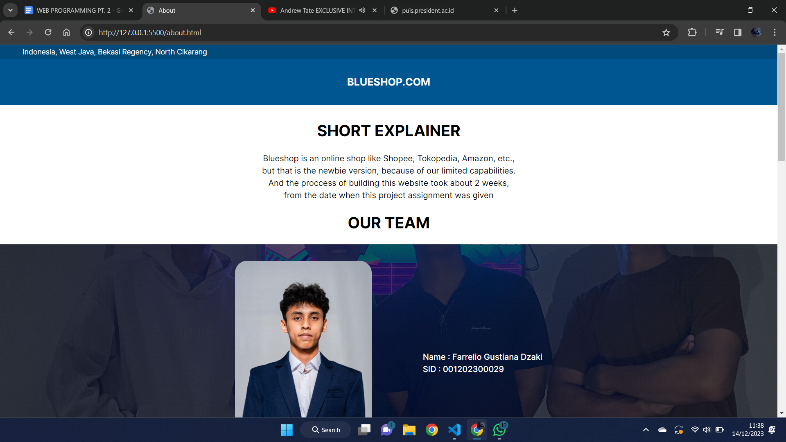

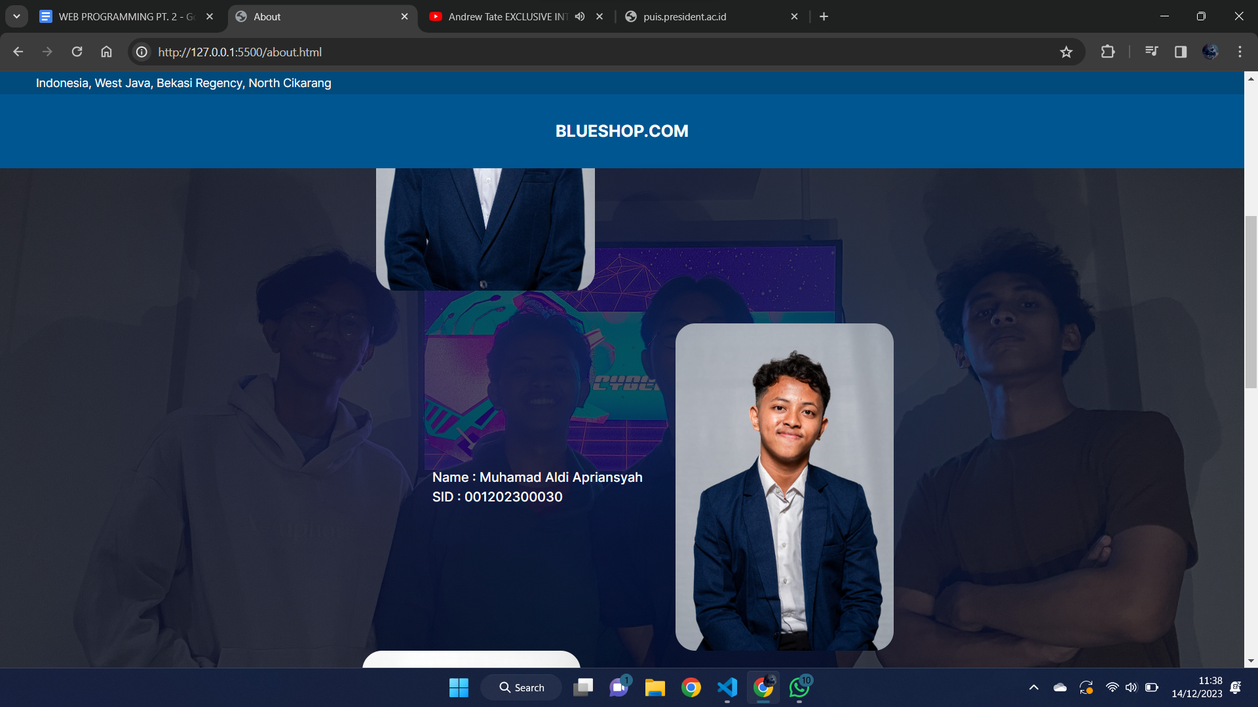

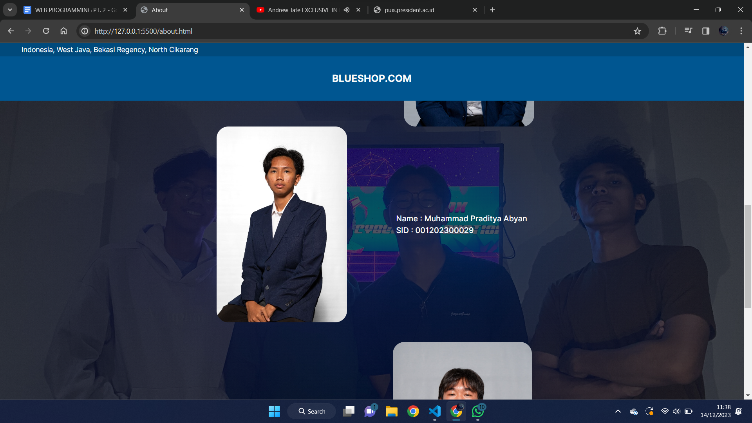

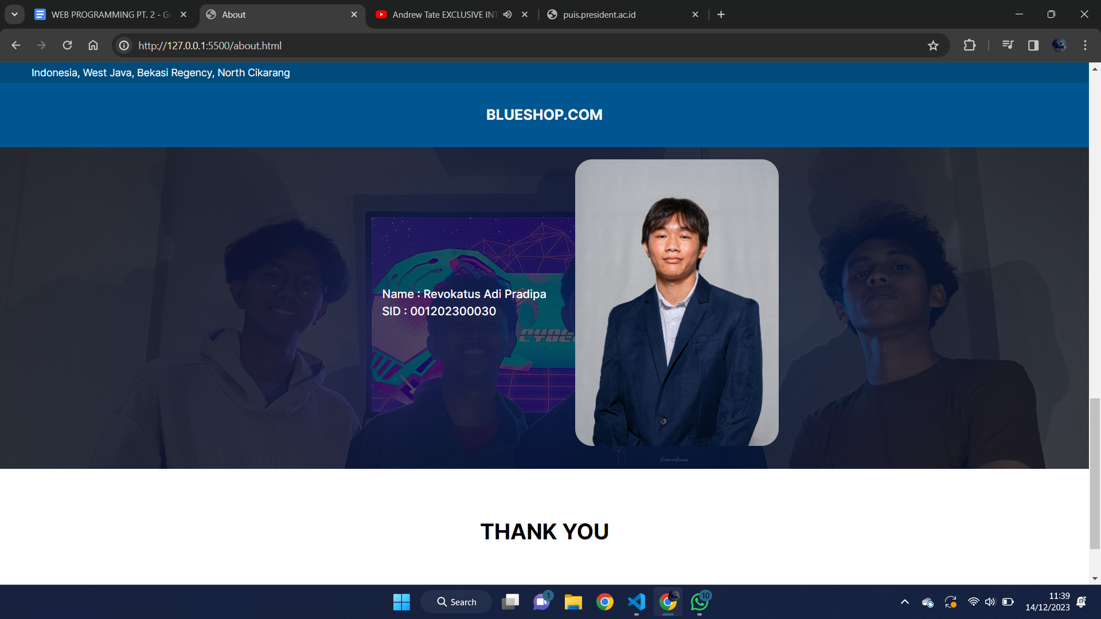

And this is our about page. It just contains a short explanation of our platform and our team. Then if you click the sign in button in the main page it will move to the sign in page.

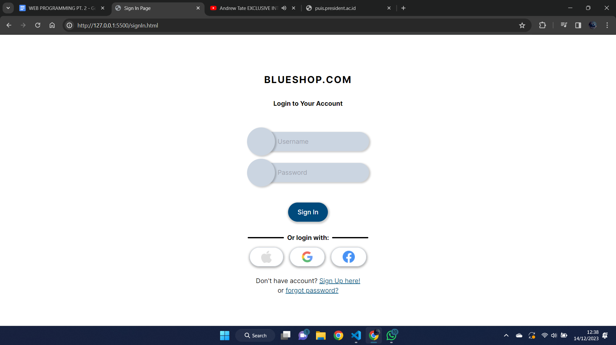

And this is our sign in page. In this sign in page if the user doesn’t put username and password but he presses the sign in button or enter, it will trigger the alert in the page. For that we use if else in the submit(). Then if the user clicks the user wants to input the username or the password, below the username input and the password input will pop up text. To do that we use **focus()** and put a css() in the function to make the text pop up. Each input has minimum characters to submit so if the user submits before fulfilling the minimum characters then it will trigger the alert, we use if else to do that. Then if the user already fulfills the minimum characters of each input, the text below each input will disappear. After the user presses the sign in button it will automatically go to the main page.

Back to the sign in page, in sign page. In the bottom of the sign in page we have two links that makes the user go to the sign up page and forget the password page. If the user moves the cursor to the “forgot password?” then it will pop a text, we’re doing that using **mousemove()** and mouseleave(). In the **mousemove()** we use css() that makes the text visible to see, and in the mouseleave() we also use css() that makes the text disappear. If the user clicks the “sign up here!” it will move the sign up page. And if the user clicks the “forgot password?” it will move to the forgot password page.

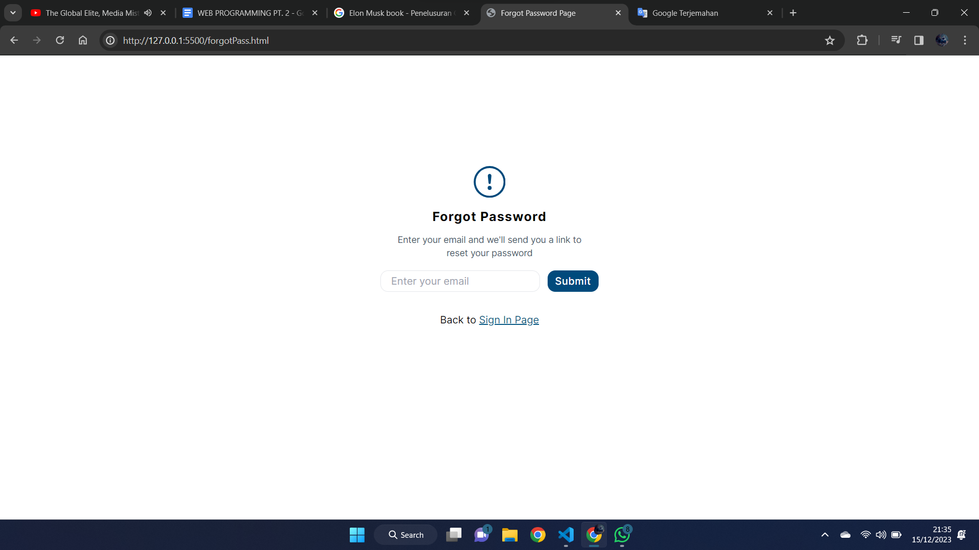

And this is our forgot password page. In this page the user enters their email and the warning icon will be changed into a check icon.

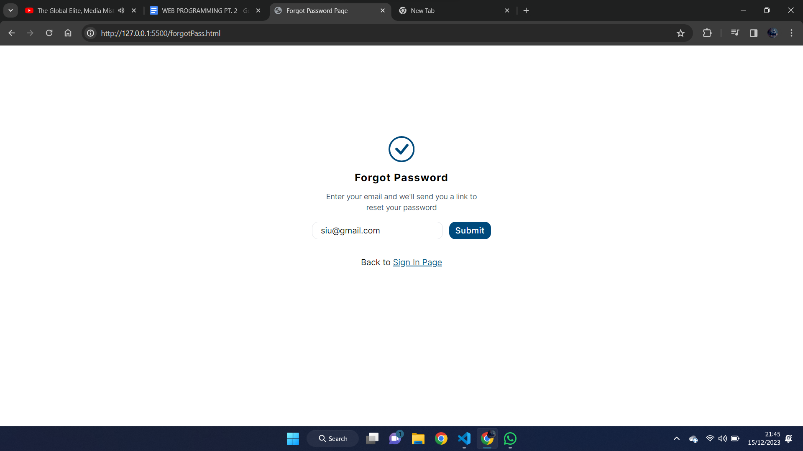

And this is the result. We do this by using two icons and one of the icons is display none and the other icon display flex. Then in the submit() if the user doesn’t enter the email it will pop up an alert(). And if the user inputs the email correctly one of the icons that contain display none we use css() in that to make it display flex and the other icon where it contains display flex we use css() to make it display none.

After that the user can go back to the sign in page by clicking the “Sign in Page”.

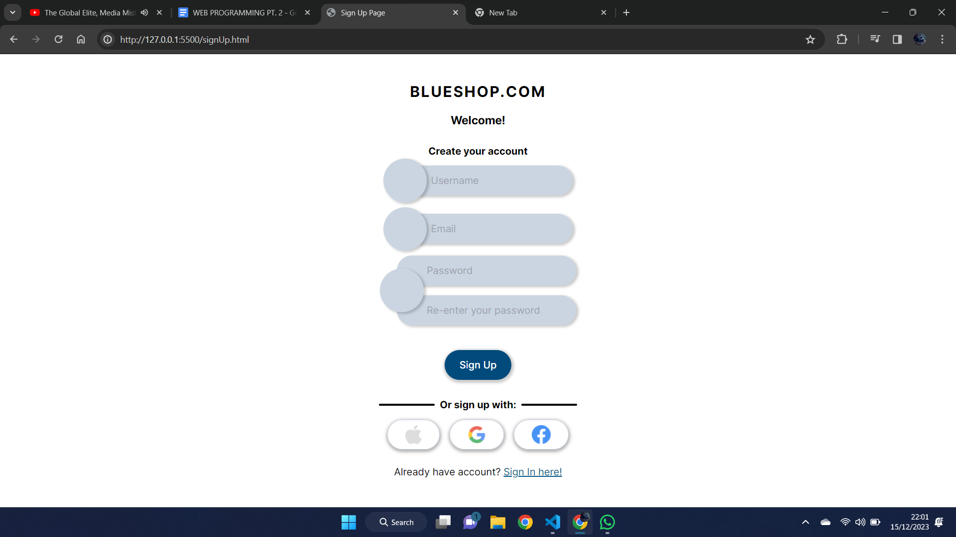

And this is our sign up page. In our sign page if the user wants to input the username and password it will show a text below the username and the re-enter password input. If the user already fulfilled the minimum characters, the text will automatically disappear. To do that we use focus() on the username input and the password input. We put css() to make the text shown. Then to make it automatically disappear when it already contains the minimum characters we use change() and we put if else inside it.

Then if the user wants to submit but the password and the re-enter password are different it will trigger the alert(). To do that we use if else inside of the submit(). Then if the user submit it by clicking the sign up button or enter it will go to the main page.

That’s all from us, Thank you.